**CODE**

CREATE TABLE accounts (

account_id NUMBER PRIMARY KEY,

customer_id NUMBER,

balance NUMBER(12, 2)

);

-- account_id, customer_id, balance

INSERT INTO accounts VALUES (101, 1, 5000.00);

INSERT INTO accounts VALUES (102, 2, 12000.00);

INSERT INTO accounts VALUES (103, 3, 7500.50);

INSERT INTO accounts VALUES (104, 4, 15000.00);

INSERT INTO accounts VALUES (105, 5, 8900.75);

INSERT INTO accounts VALUES (106, 6, 3000.00);

INSERT INTO accounts VALUES (107, 7, 2200.00);

INSERT INTO accounts VALUES (108, 8, 9800.00);

INSERT INTO accounts VALUES (109, 9, 13400.25);

INSERT INTO accounts VALUES (110, 10, 4100.00);

COMMIT;

SELECT * FROM ACCOUNTS;

CREATE OR REPLACE PROCEDURE ProcessMonthlyInterest IS

BEGIN

UPDATE accounts

SET balance = balance + (balance * 0.01);

COMMIT;

END;

EXEC ProcessMonthlyInterest;

SELECT * FROM ACCOUNTS;

**OUTPUT**

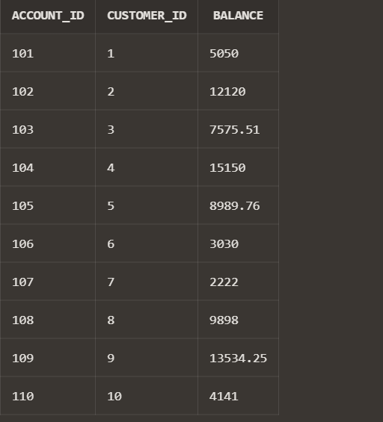

**CODE**

CREATE TABLE employees (

emp_id NUMBER PRIMARY KEY,

name VARCHAR2(100),

department VARCHAR2(50),

salary NUMBER(10, 2)

);

-- emp_id, name, department, salary

INSERT INTO employees VALUES (1, 'John Smith', 'Sales', 50000.00);

INSERT INTO employees VALUES (2, 'Alice Brown', 'HR', 55000.00);

INSERT INTO employees VALUES (3, 'Mike Johnson', 'Sales', 62000.00);

INSERT INTO employees VALUES (4, 'Emily Davis', 'IT', 70000.00);

INSERT INTO employees VALUES (5, 'David Wilson', 'Sales', 58000.00);

COMMIT;

SELECT * FROM EMPLOYEES;

CREATE OR REPLACE PROCEDURE UpdateEmployeeBonus (

p_department IN VARCHAR2,

p_bonus_percent IN NUMBER

) IS

BEGIN

UPDATE employees

SET salary = salary + (salary * p_bonus_percent / 100)

WHERE department = p_department;

COMMIT;

END;

EXEC UpdateEmployeeBonus('Sales', 10);

**OUTPUT**

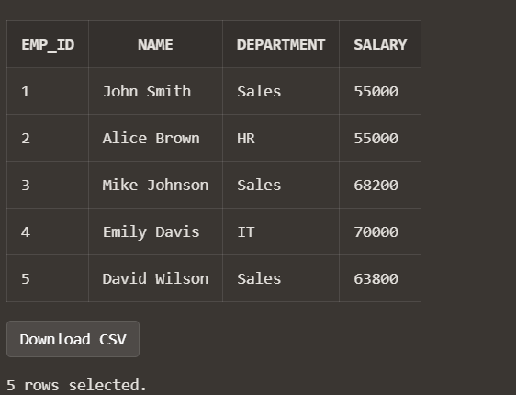

**CODE**

CREATE OR REPLACE PROCEDURE TransferFunds (

p_from_account IN NUMBER,

p_to_account IN NUMBER,

p_amount IN NUMBER

) IS

v_from_balance NUMBER;

BEGIN

-- Check if source account has enough balance

SELECT balance INTO v_from_balance

FROM accounts

WHERE account_id = p_from_account;

IF v_from_balance < p_amount THEN

RAISE_APPLICATION_ERROR(-20001, 'Insufficient funds in source account.');

END IF;

-- Deduct from source

UPDATE accounts

SET balance = balance - p_amount

WHERE account_id = p_from_account;

-- Add to destination

UPDATE accounts

SET balance = balance + p_amount

WHERE account_id = p_to_account;

COMMIT;

END;

EXEC TransferFunds(102,107,2000);

SELECT * FROM ACCOUNTS;

**OUTPUT**

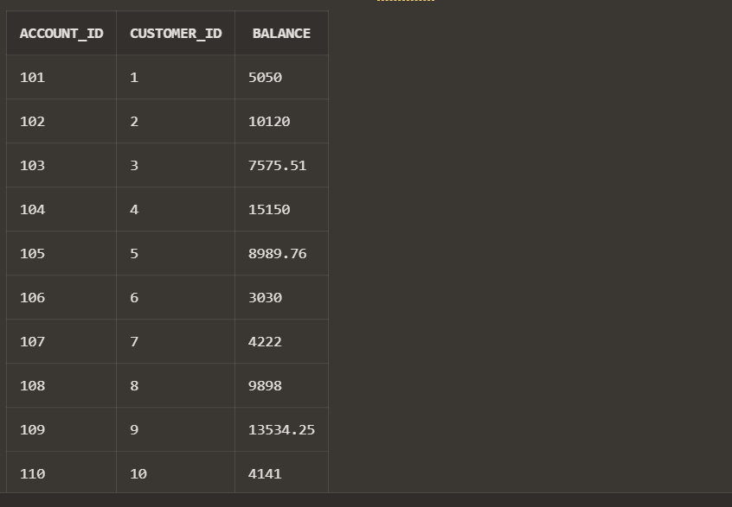

Link :”<https://livesql.oracle.com/ords/livesql/s/dmojw9bi9tys1vgxkosijlh92>”